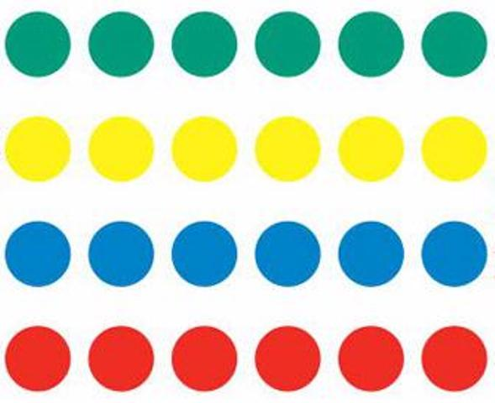

1. Decide who will be the “Spinner,” the “Recorder,” and the “Player.”
2. The “Spinner” spins the spinner and the “Player” plays Twister.
3. When the “Player” lands on a color, the “Recorder” tallies all the colours and body parts that the player has landed on with the game spinner and records the tallies in the chart.
4. When the “Player” has had 10 turns and has properly been tallied, rotate jobs with the other group members.
5. When everyone has had a chance to play Twister, use the data gathered to make a graph and answer math problems in the Math Centers Work Book.

Graphing

Directions: Next to each colour and body part, make tally makrs for how many times you landed on that colour and body part. Write the total in the frequency table.

|  |  |  |
| --- | --- | --- |
| Colour/Body Part | Tally Marks | Total |
| Green |  |  |
| Blue |  |  |
| Yellow |  |  |
| Red |  |  |
| Right Hand |  |  |
| Left Hand |  |  |
| Right Foot |  |  |
| Left Foot |  |  |
| Air |  |  |

Graphing

Create a Bar Graph using your tally chart.

1. Compare your data with your group members.
   1. Who landed on “Blue” the most and how many times? _______________________________________________
   2. Showing your work, how many times did your and your group members land on feet in total? *Remember there is “Left foot” and “Right foot.” Write your answer in a full sentence.

Graphing