Inquiry-Based Unit Plan: Grade 8 Social Studies
Japan from Isolation to Adaptation
Michelle Leafloor
ED 3601
Professor Rick Homan
University of Lethbridge

Table of Contents

- Japan from Isolation to Adaptation: Unit Introduction
- Unit Planning Organizer
- Lesson Overview
- Lesson Plans (1-5)
- Performance Assessment Task and Evaluation Tool
- Annotated List of Resources

Japan from Isolation to Adaptation – Unit Introduction

Unit Foundations
This unit was carefully planned to incorporate the Alberta Social Studies Program of Studies program rationale, philosophy, and foundations. The lessons were formed around the Values and Attitudes; Knowledge and Understanding; and the Skills and Processes Outcomes. By formulating the unit in this manner it enables and encourages students to examine issues, to respond critically and creatively, and to make informed decisions as individuals as a citizens of Canada (Alberta Education, 2005).

Core Concepts of Citizenship and Identity
Students learn about being responsible citizens in their families, schools, and communities and before a student can feel a sense of belonging in the context of the world around them, they must first have a sense of their personal identity. This unit Japan from Isolation to Adaptation creates multiple learning opportunities for students to recognize the relationship between citizenship and identity. It incorporates the understanding that identity is shaped by multiple personal, social, linguistic, cultural, and geographic factors (Alberta Education, 2005; Fitton, Goodman, & O'Connor, 2007b).

Aboriginal Perspectives
It was surprisingly, quite easy to fit in Canadian Aboriginal perspectives into this unit. The Aboriginal perspectives were incorporated with the comparison of the similarities and differences of the Ainu, the indigenous people of Japan, and Canadian Aboriginals. Comparisons are also made through the deep ties to nature in within the Shinto religion of the Japanese people and the beliefs of Aboriginal peoples across Canada.

Strands of Social Studies
This unit follows the strands of Social Studies identified within the Alberta Program of Studies, reflecting the interdisciplinary nature of social studies:
- Time, Continuity, and Change (TCC)
- The Land: Places and People (LPP)
- Power, Authority, and Decision Making (PADM)
- Culture and Community (CC)
- Global Connections (GC)
- Economics and Resources (ER)
By incorporating these strands into teaching the unit it allows students to increase their depth of understanding and to begin to think more critically and creatively (Alberta Education, 2005; Fitton, et al., 2007b).

Inquiry Based
The teaching and activities included throughout the unit have the inquiry-based model at the core. Students have opportunities within the unit to be introduced to and to continue to develop inquiry skills that have been established in earlier grades. The activities provide students with the opportunity to formulate research questions, identify and locate sources of information and then record and communicate their findings (Alberta Education, 2005; Fitton, et al., 2007b). It is through this inquiry process that different dimensions of thinking are incorporated such as:
- Critical Thinking
- Creative Thinking
- Historical Thinking
- Geographic Thinking
- Decision Making and Problem Solving
- Metacognition
The inquiry-based unit also infuses the use of technology throughout the research process, meeting many of the Media Literacy Skills outlined by Alberta Education (Alberta Education, 2005).

Cooperative Learning
The unit is mostly founded on the principal of cooperative learning, in that members of a group are respected for their individual skills and contributions while building group consensus through cooperation, sharing, and responsibility. Providing a collaborative learning environment affords opportunity for peer support, facilitates interaction and cooperation, while also encouraging risk taking, exploration and investigation (Fitton, et al., 2007b).

Accommodation and Differentiation
Every lesson within the unit has infused techniques that accommodate a variety of different learner needs. The lessons have been planned with the understanding of the different learning styles (auditory, visual, kinesthetic) as well as multiple intelligences (linguistic, logical, musical, kinesthetic, etc.). Lessons can also be easily adapted to specific learner needs, but are not present within this unit plan.

Worldviews: Contact and Change

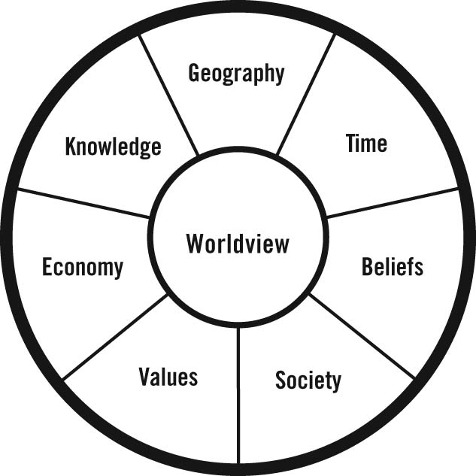
The bases of the unit Japan from Isolation to Adaptation comes from the textbook used for Grade 8 Social Studies, Worldviews: Contact and Change (Fitton, Goodman, & O'Connor, 2007a). It is through this visual model that helps students understand how worldviews are developed. In this case the unit is investigating the worldview of Japan. Lessons and activities are created with the Worldview Icon (above) in mind. Chapter 12 of the unit consists of the Geography, Time, Beliefs, and Value icons. The core concept of the chapter investigates how nature influences the Japanese worldview. Chapter 13 incorporates the Economy, Values and Society icons. The chapter’s main focus understands how social systems, in particular the Feudal system of Edo Japan have impacted the Japanese worldview.

References

Alberta Education. (2005). Social studies kindergarten to grade 12: Program rationale and philosophy. Edmonton, AB, Canada: Alberta Education Retrieved from http://www.education.alberta.ca/teachers/program/socialstudies/programs.aspx.
Fitton, A., Goodman, D. M., & O'Connor, E. (2007a). Worldviews: Contact and change. Don Mills, ON: Pearson Education Canada.
Fitton, A., Goodman, D. M., & O'Connor, E. (2007b). Worldviews: Contact and change teacher resource. Don Mills, ON: Pearson Education Canada.

