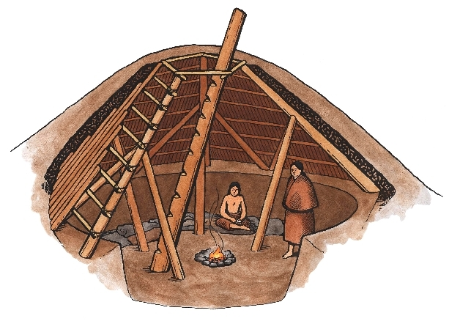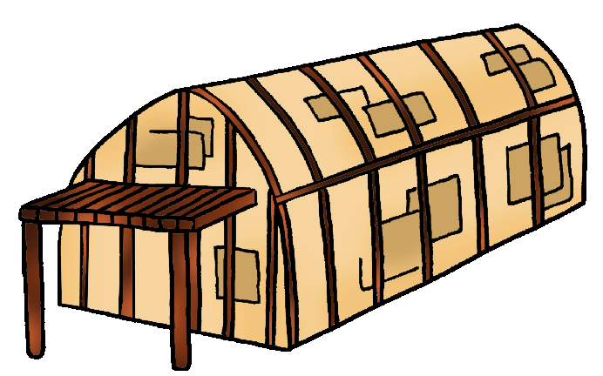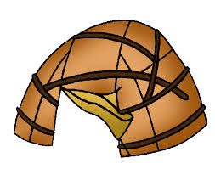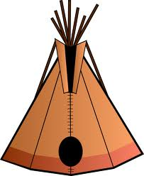

Pit house

Igloo

Longhouse

wigwam

**tipi**

The type of homes that aboriginal people built depended on the kinds of materials they could find nearby, the kind of weather they had to shelter from, and how often they moved from place to place. Some tribes, who did a lot of hunting and gathering created houses, like tipis and wigwams that could be packed up or left behind. Others who lived in permanent villages could make more solid homes from materials like logs and bark.

**Graphing Math Center**

Traditional Aboriginal Homes

While hunting out on the sea ice, they would build igloos only as a temporary shelter from the wind and cold. However some Inuit groups began to use **igloos** for the entire winter.

The Algonquians of the Eastern Woodlands lived in small villages near rivers and lakes in dome-shaped homes called **wigwams**. They built the frame of the house with young saplings set in a circle and tied together at the top, and covered the frame with mats woven from cattails as well as birch bark.

The Iroquoians were farmers who did not need to move around so their houses could be much larger and sturdier. They built elm or cedar-bark “**longhouses**” which were big enough for several families to live in together.

Many of the Plateau tribes lived in log huts covered with bark or grass. In the winter, some lived in “**pit houses**.” These houses were holes dug into the ground, with a cone-shaped roof held up by wooden poles, and covered with branches and dirt. They used a ladder to enter and leave through an opening at the top.

On the Plains most tribes moved around a lot to hunt buffalo and gather plants for food. The most common home was a **tipi**, built with long poles that were tied together at the top and covered by buffalo hides.

1. Using the worksheet with the different types of Aboriginal homes provided at the center create:
   1. A **tally chart** of each type of home. Make your tally chart on the matching center page that is in your Math Centers Work Book. Make sure you properly label your tally chart with **a title**, **column titles**, and **row titles**.
   2. A **pictograph** of each type of home. On the same work book page as your tally chart make your pictograph. Cut and paste the worksheet pictures to use in your pictograph. Make sure you properly label the important parts of your graph (**title, vertical axis**, **horizontal axis, categories**)
2. Use the information you have collected in your tally chart and pictograph to answer the following questions in your Math Centers Work Book.
   1. How many aboriginal homes are there **in total?**
   2. Which type of home is there the **most** of?
   3. Which type of home is there the **least** of?
   4. How **many more** tipi’s **than** longhouses are there?
   5. Are there any types of home that have the **same** amount?

Graphing activity