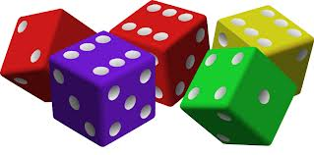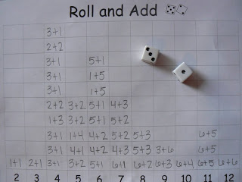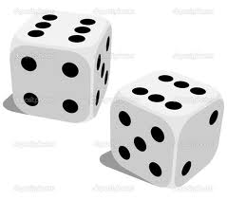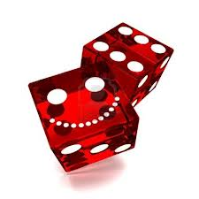

1. Complete worksheet questions from the data collected on the “Roll and Add” graph.
2. Each group member will use a 2 dice.
3. Roll both dice at the same time. Roll 30 times. Each roll; add the face value of each dice and record in the corresponding column of the worksheet in the Math Center Work Book. Example below.

**Roll**

**And**

**Graph**

1. What type of graph did you create on the “Roll and Add” worksheet? ________________________________________________________
2. What **sum** was rolled **most frequently** (the most)? _____________
3. What **sum** was rolled the **least**? ___________
4. Write down **3** more observation from your graph. Eg. The difference between the sum rolls of 6 and the sum rolls of 11 is 1.

________________________________________________________________________________________________________________________________________________________________________________________________________________________________________________________________________________________________________________________________________________________________________________________________________________________________________________________________________________________

Roll and Graph